**VNPaySubsystem Document**

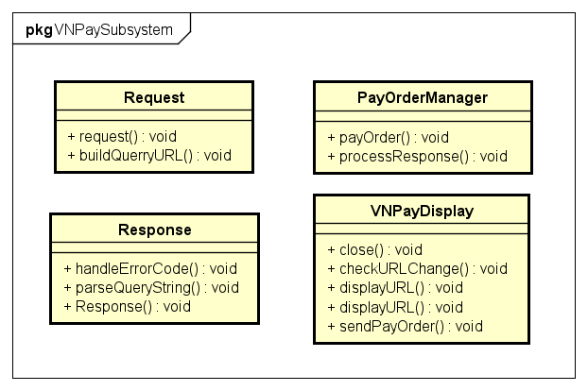

1. PayOrderManager

- Class description: manages payment order

- Operation:

+ void payOrder(amount: double, orderInfo: String, client: Client): process payment order

+ void processResponse(queryString): process response from VNPay

2. Request

- Class description: represents a payment request

- Operation definition:

+ void Request(amount: double, orderInfo: String): initialize a payment request

+ void buildQueryURL(): build query URL for the request

3. VNPayDisplay

- Class description: handles display and interaction related to VNPay

- Operation definition:

+ void sendPayOrder(queryURL): send payment order to VNPay

+ void displayURL(url): display URL

+ void displayURL(vnp_ReturnURL_With_Response): display URL with response

+ void checkURLChange(): check URL for change

+ void close(): close VNPay display

4. Response

- Class description: represents a response from VNPay

- Operation definition:

+ void Resonse(queryString): initialize a response object

+ void parseQueryURL(): parse query URL from response

+ void handleErrorCode(): handle error code and throw relevant exception